**About Jira Tool:**

**JIRA** is a tool developed by Australian Company Atlassian. This software is used for **bug tracking, issue tracking,** and **project management**. The JIRA full form is actually inherited from the Japanese word “Gojira” which means “Godzilla”. The basic use of this tool is to track issue and bugs related to your software and Mobile apps.

It is also used for project management. The JIRA dashboard consists of many useful functions and features which make handling of issues easy. Some of the key features are listed below. Now in these Jira tutorials, let’s learn JIRA[Defect](https://www.guru99.com/defect-management-process.html)and Project tracking software with this Training Course.

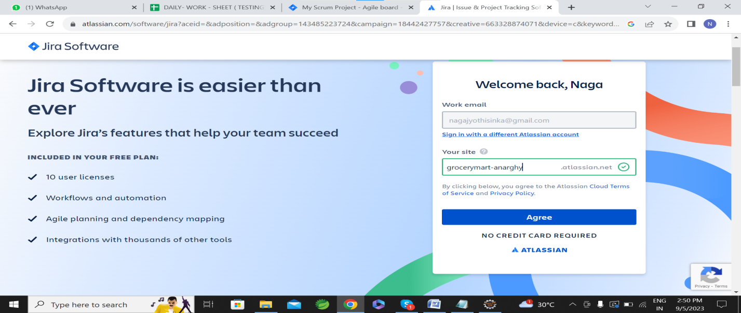

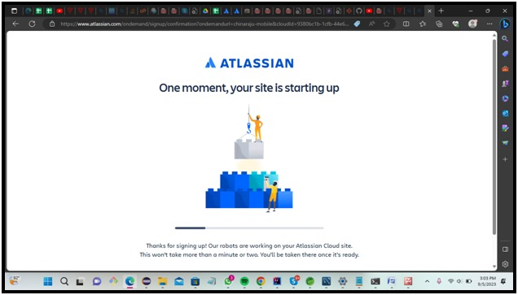

**Selecting Template for my Project**:

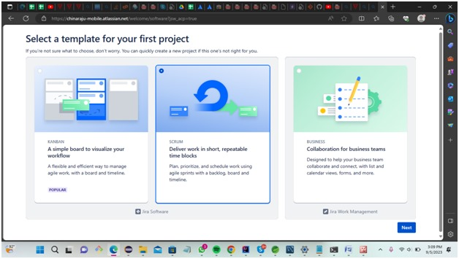

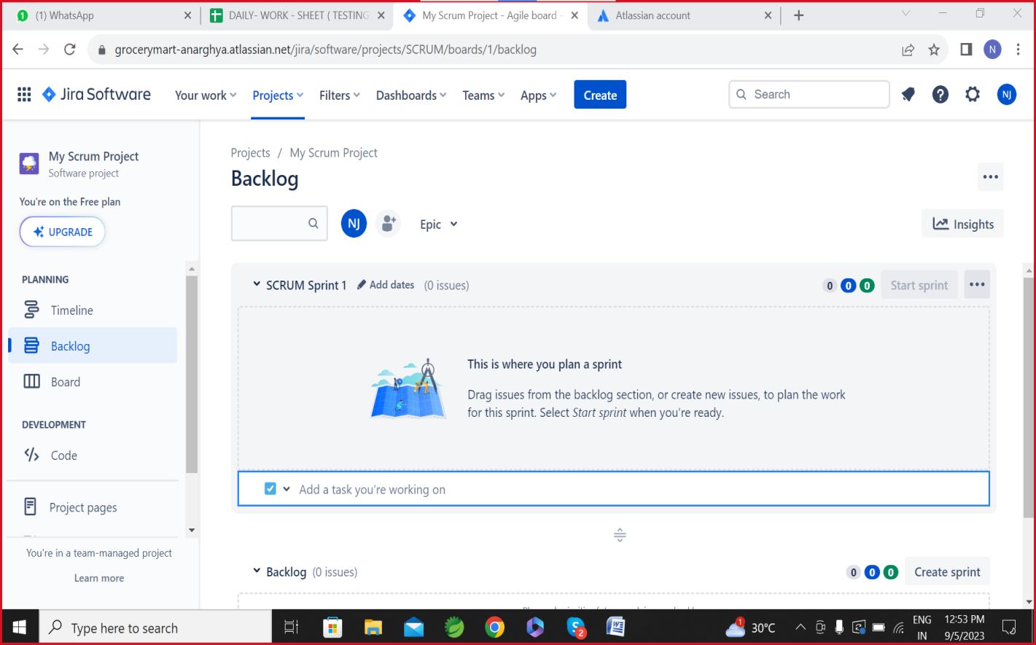

**Start Sprint:**

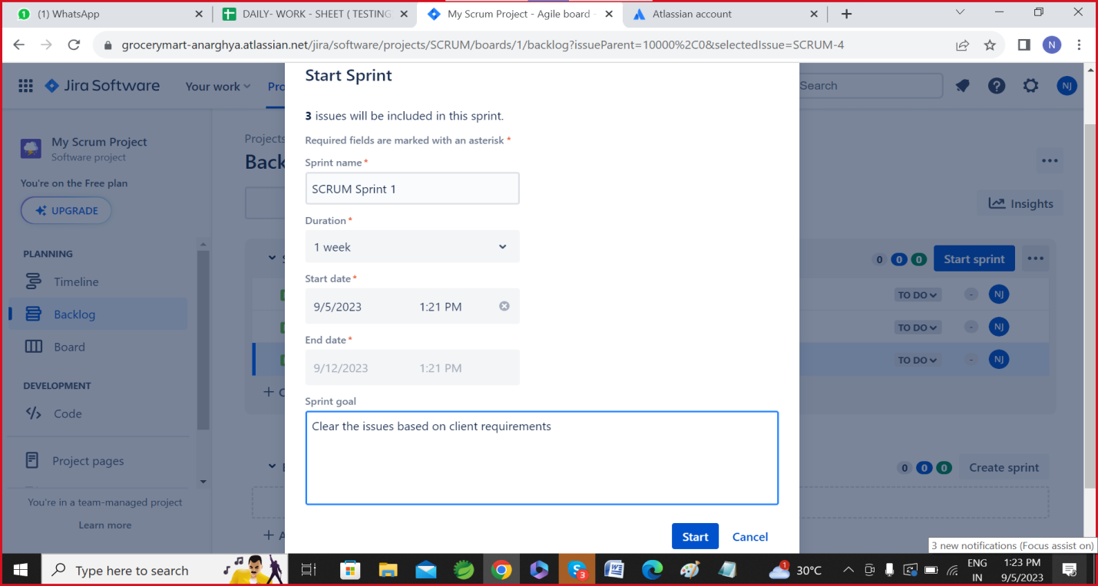

**Create a Home page an Epic:**

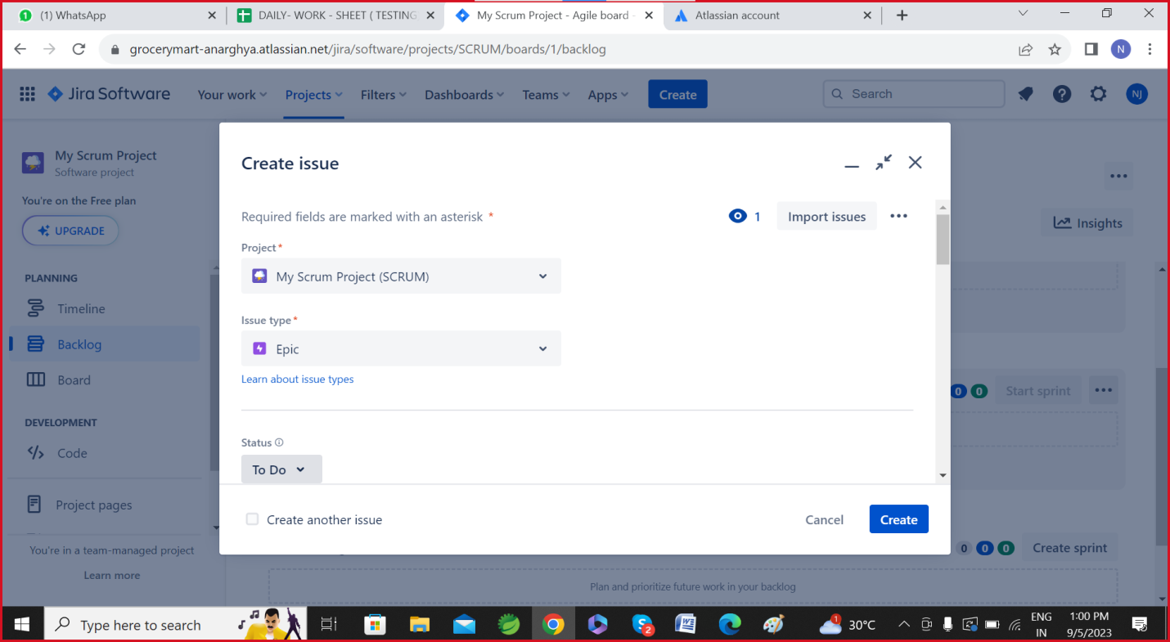

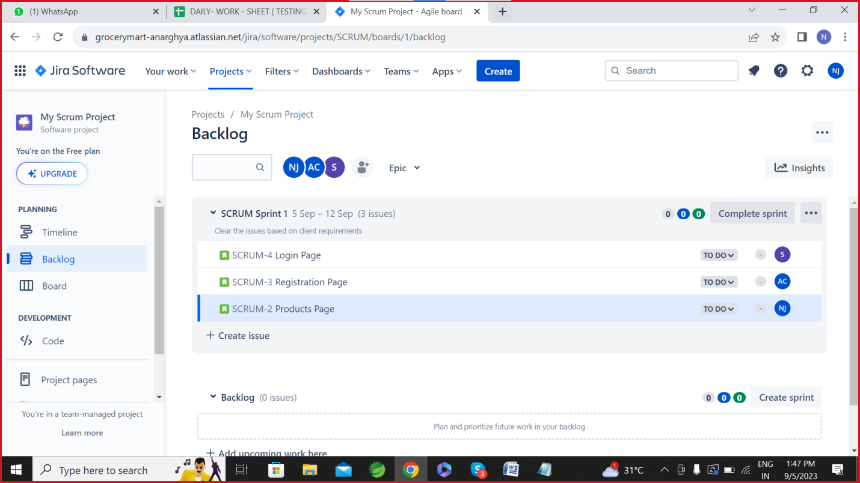

**Creating Home page:**

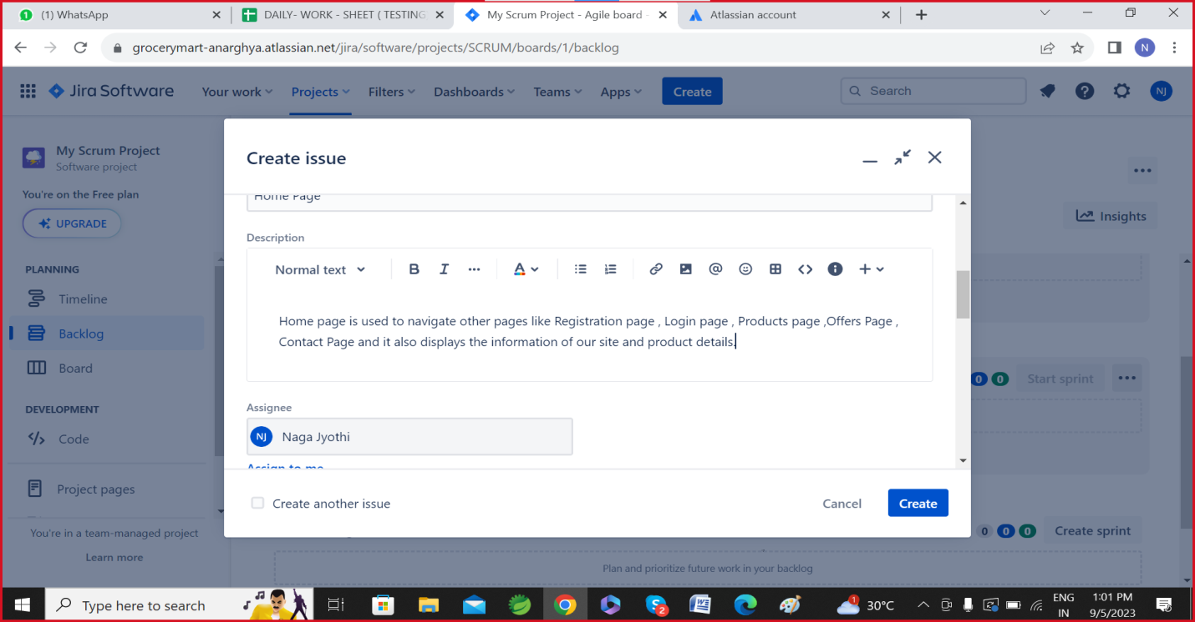

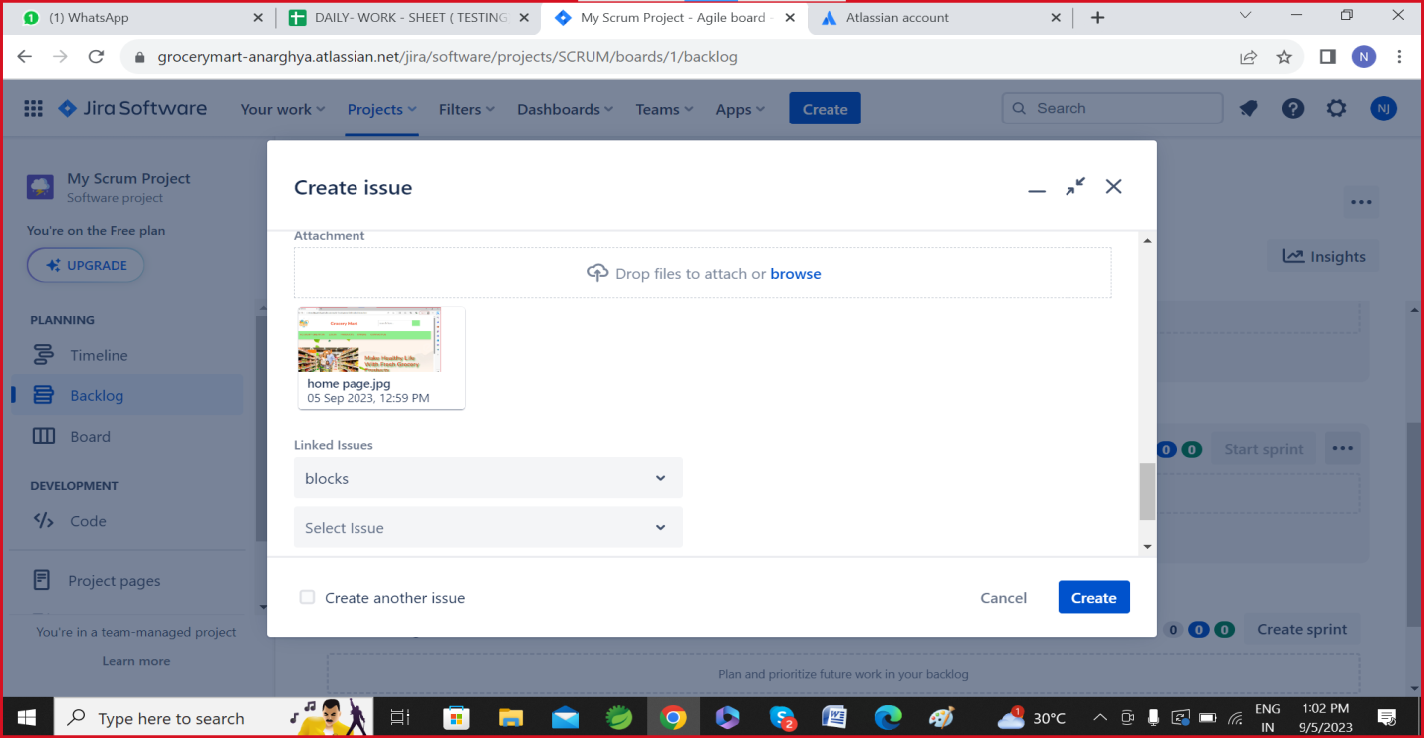

**Creating Products Page:**

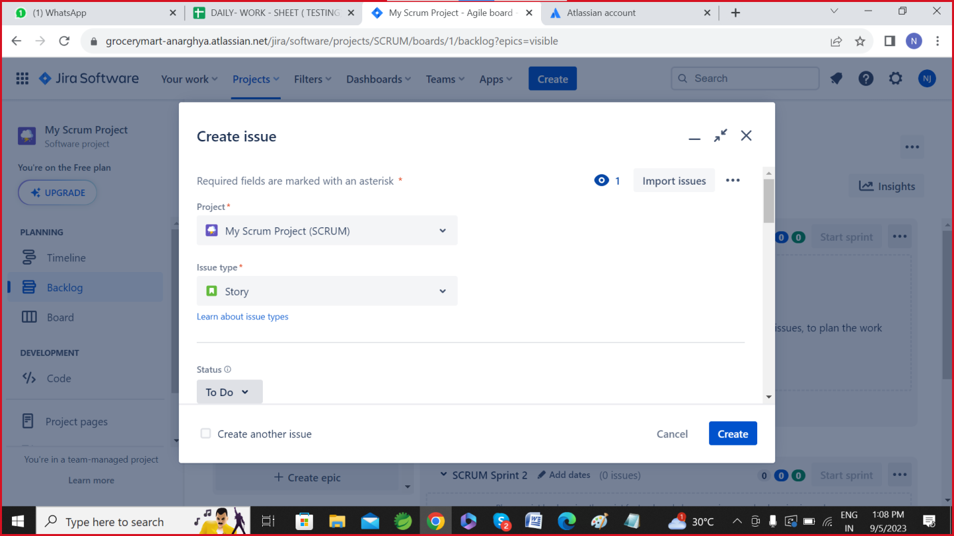

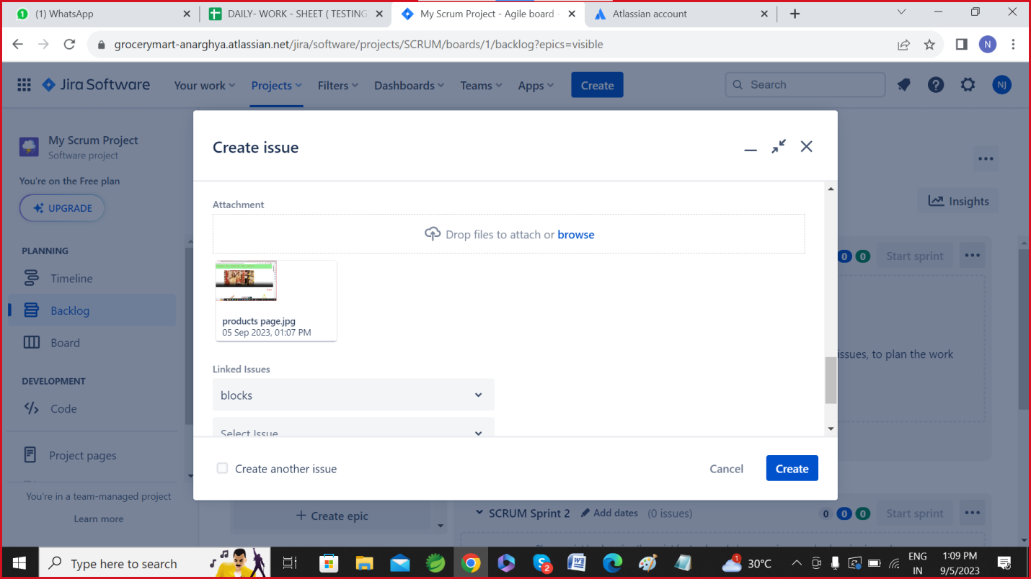

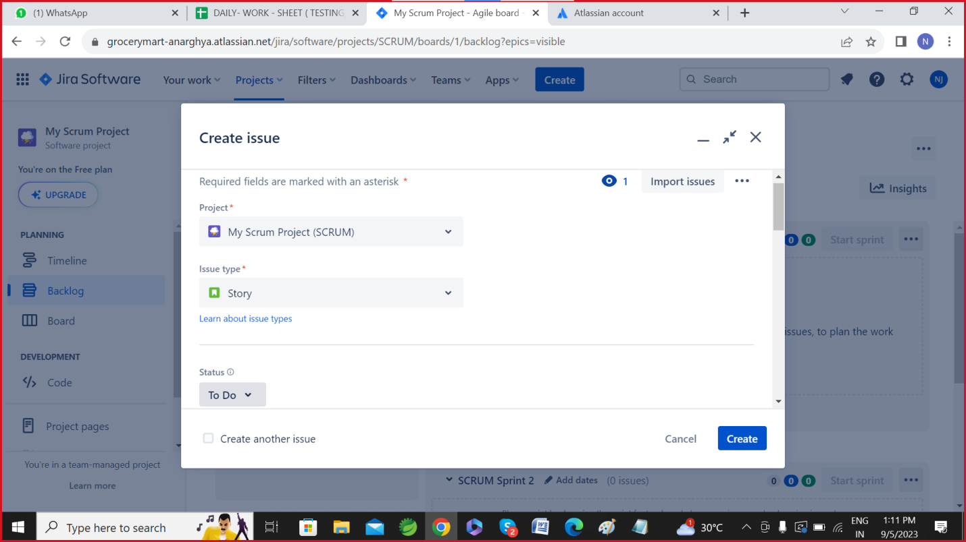

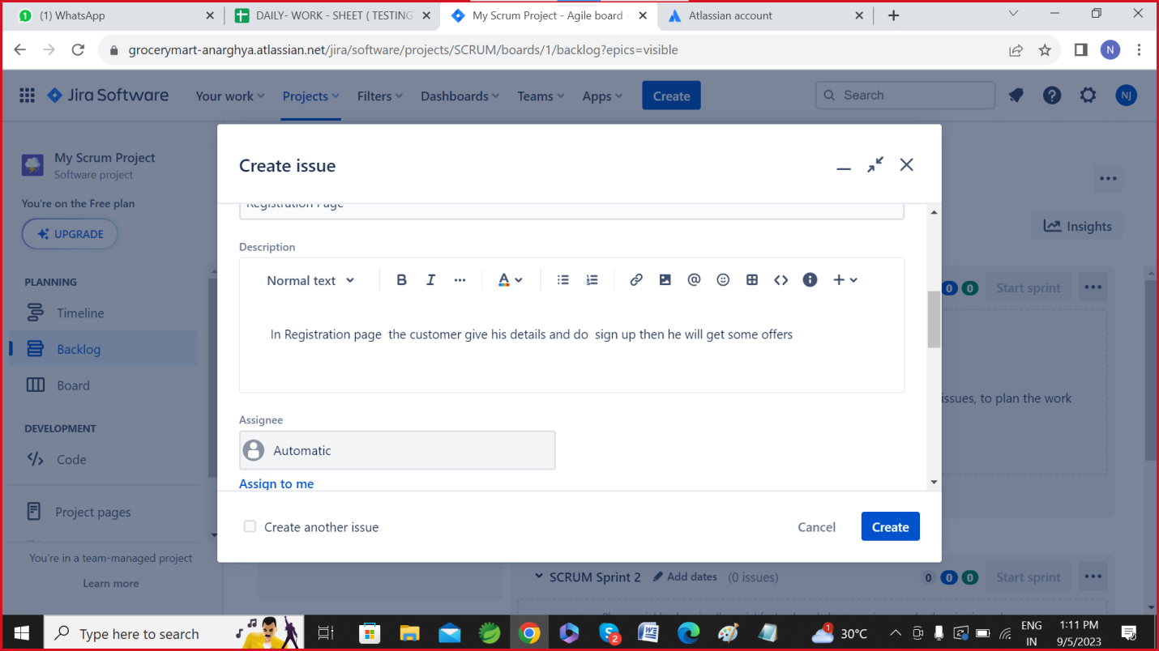

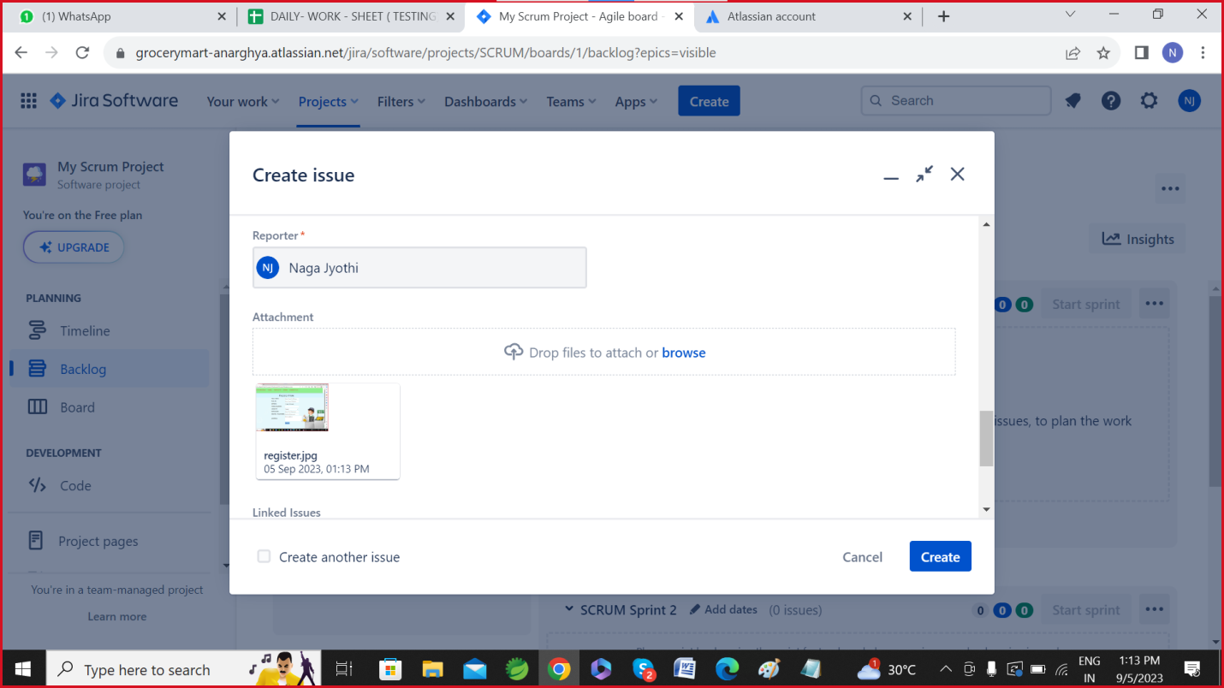

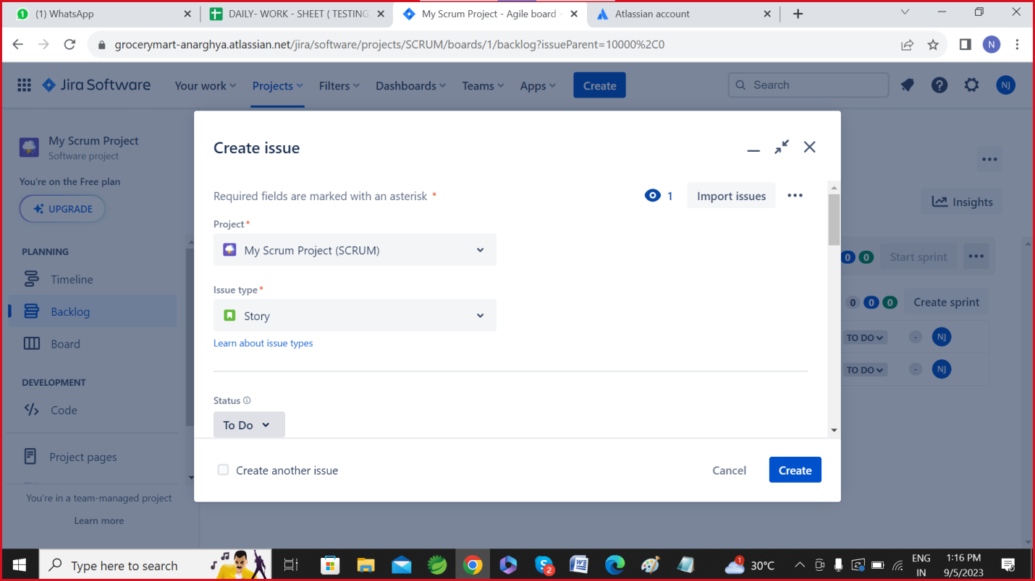

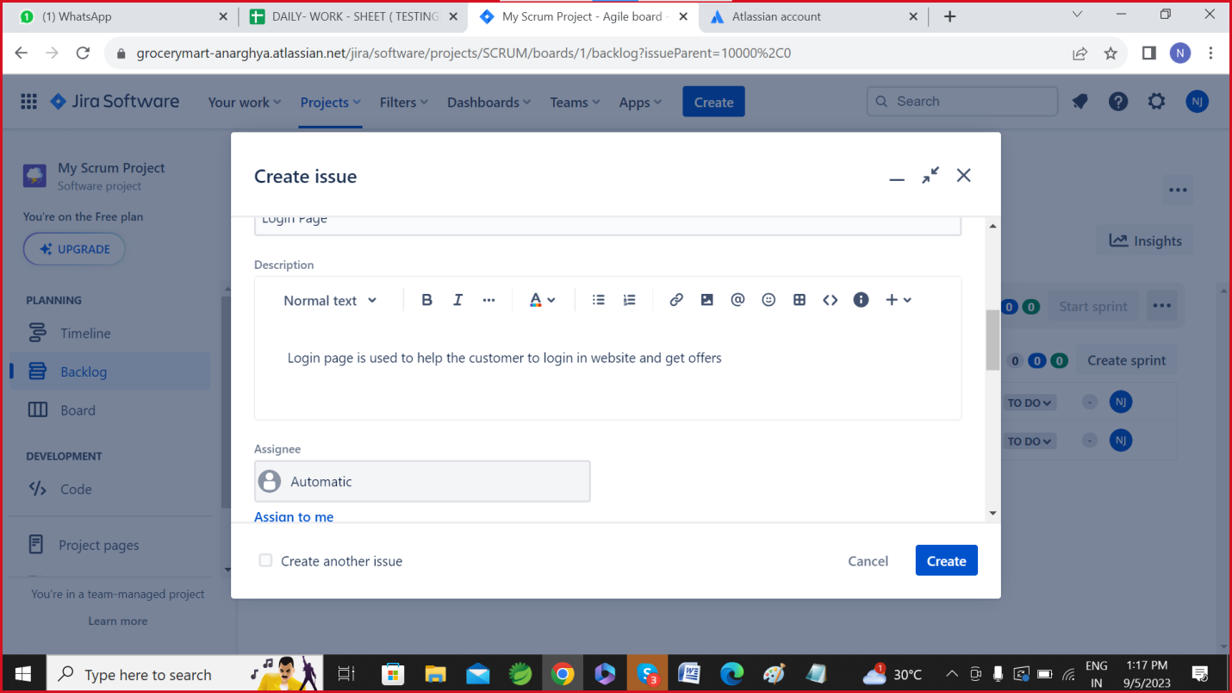

**Creating Issue Login Page:**

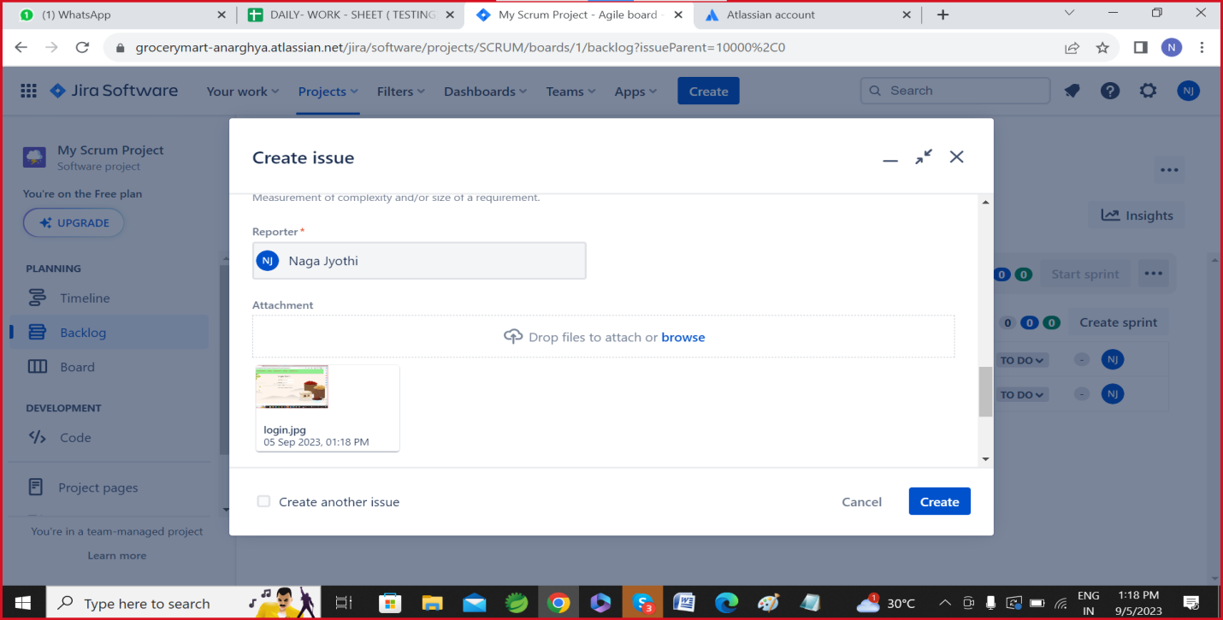

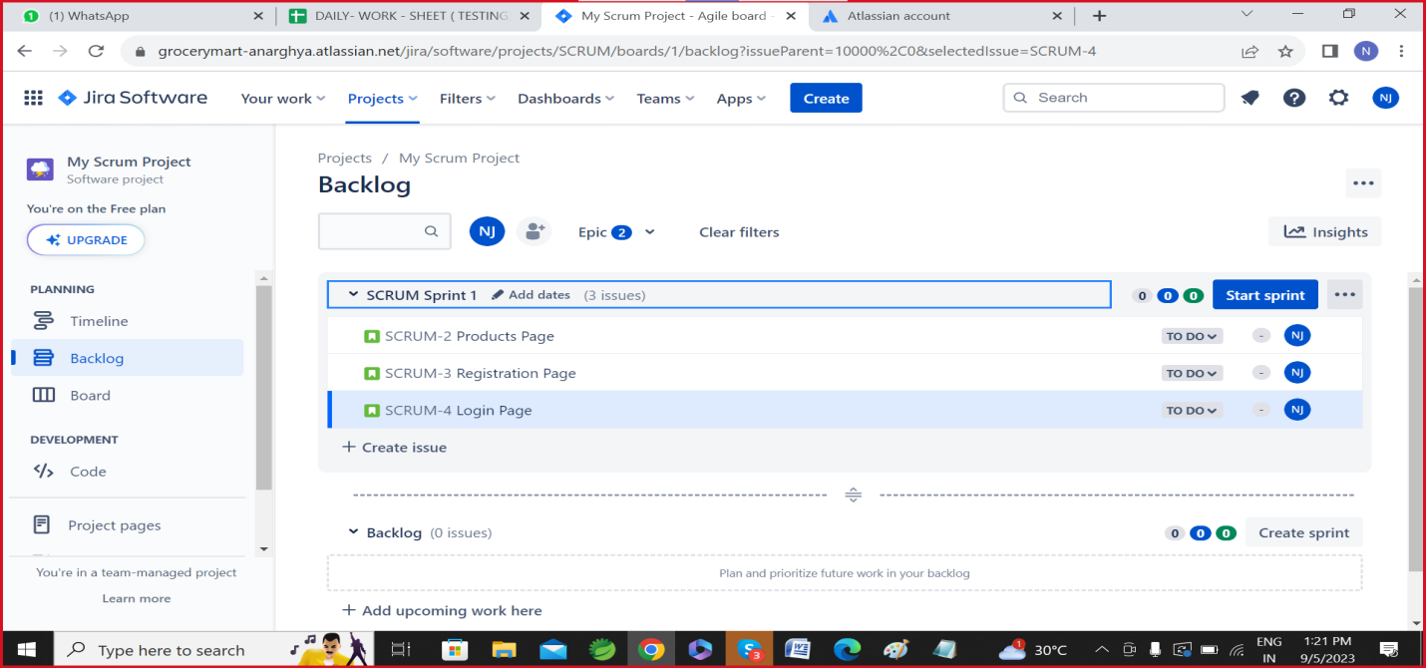

**Scrum Sprint1:**

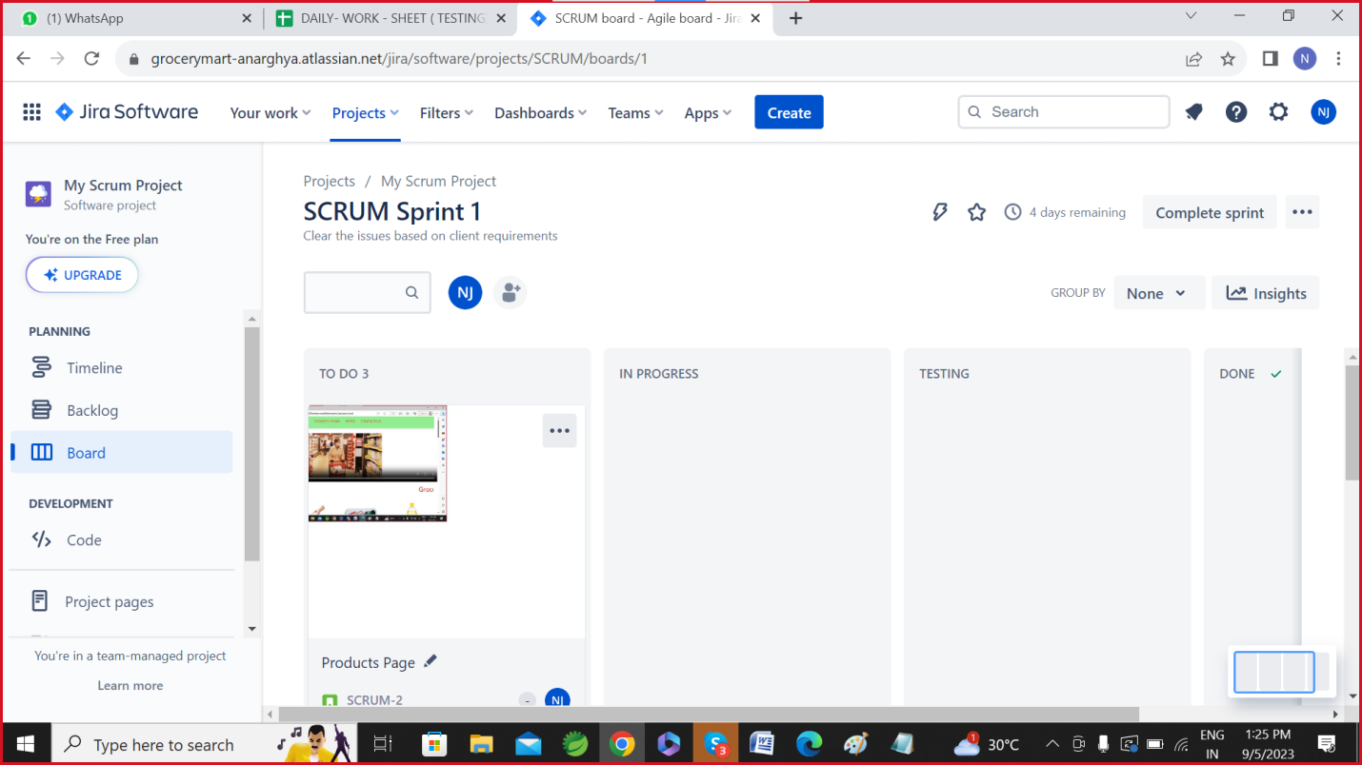

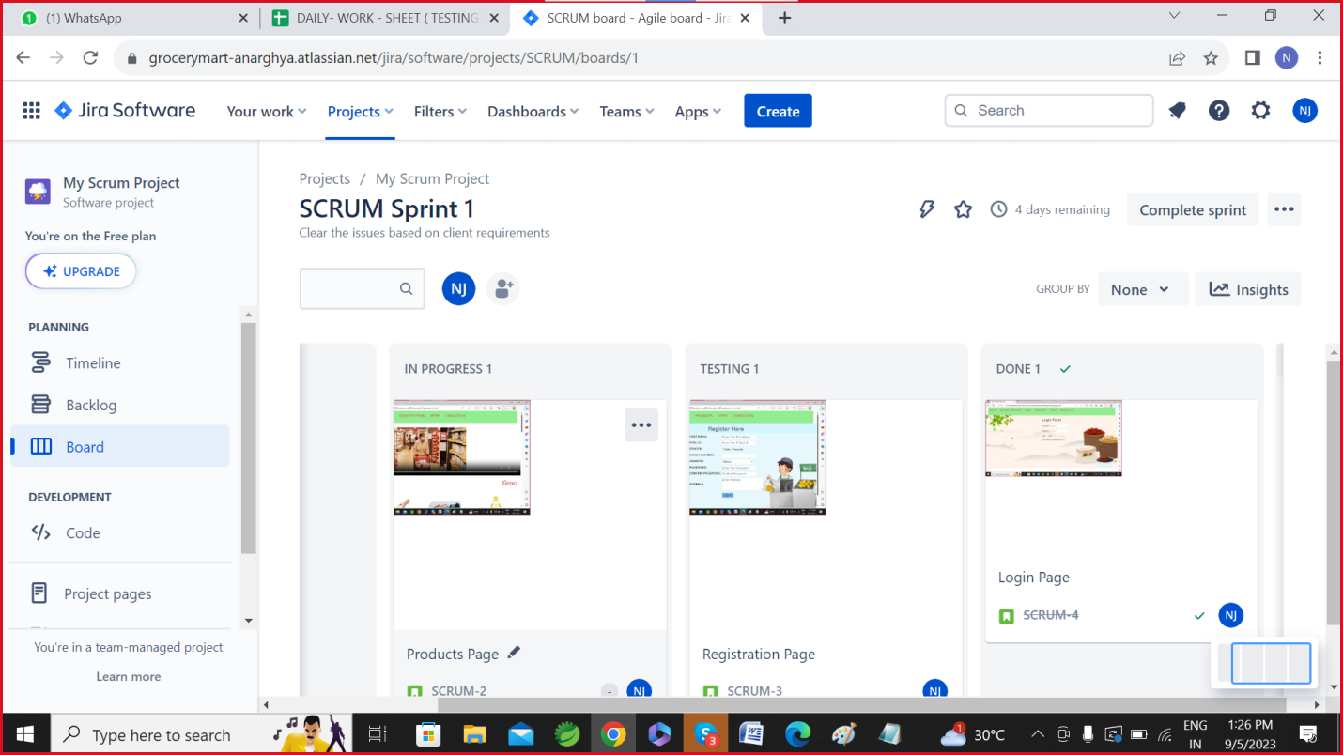

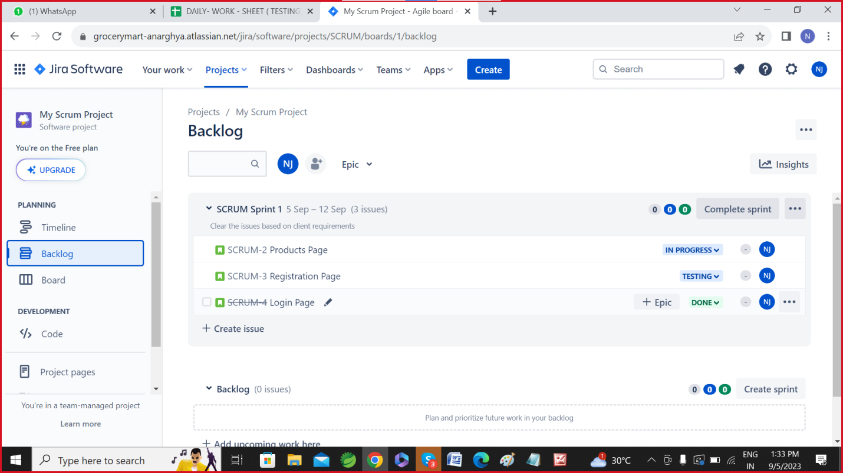

**Creating Backlog:**

